Line
# Source: AI Source: Provided by: [Data Path: Persons Table -> ID Column: 1, Name_En Column: Motasem Essam] -> From: [ChatGPT] on [7/25/2026]
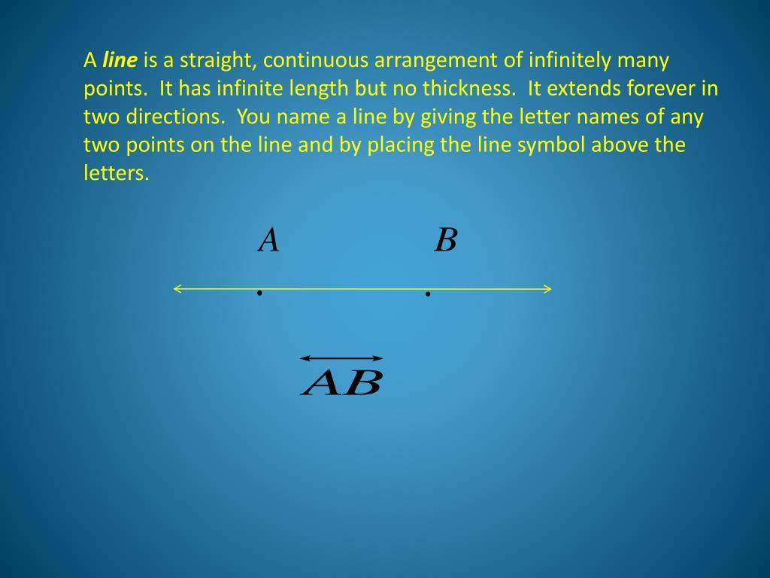
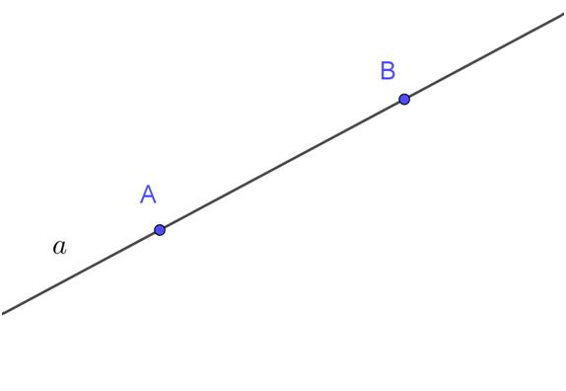
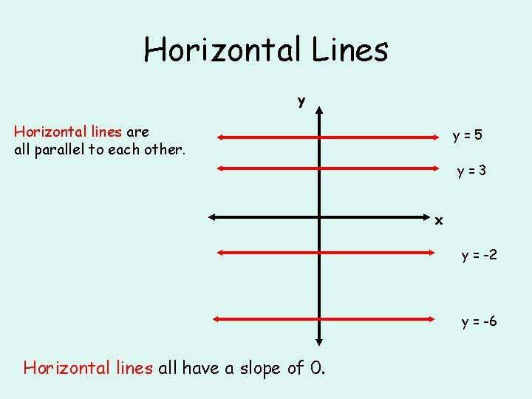
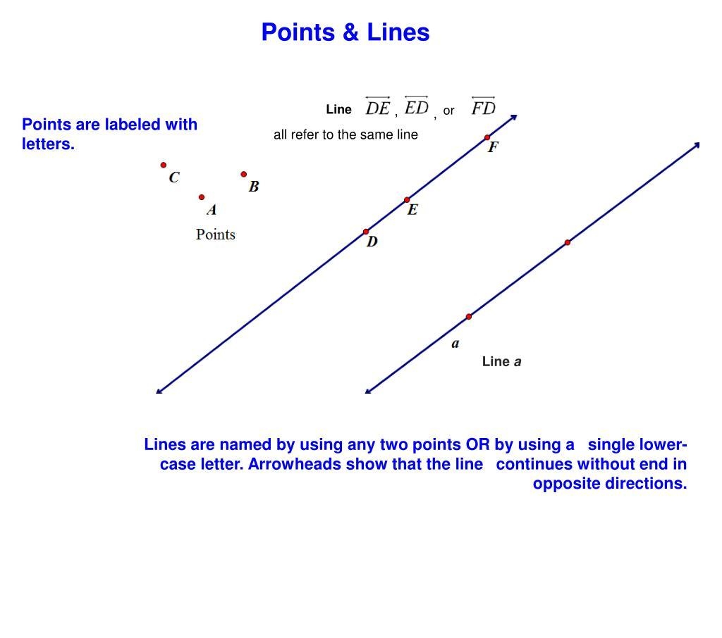

Definition
# Source: AI Source: Provided by: [Data Path: Persons Table -> ID Column: 1, Name_En Column: Motasem Essam] -> From: [ChatGPT] on [7/25/2026]
A Line is a straight one-dimensional geometric object that extends infinitely in both directions without beginning or end. It consists of an infinite number of points and has length but no width or thickness.
A line is one of the fundamental objects in plane geometry and is used to define many other geometric concepts.

Characteristics
# Source: AI Source: Provided by: [Data Path: Persons Table -> ID Column: 1, Name_En Column: Motasem Essam] -> From: [ChatGPT] on [7/25/2026]
A Stright line:
- Extends infinitely in both directions.
- Has no endpoints.
- Is perfectly straight.
- Has only one dimension (length).
- Contains infinitely many points.
- Has no width, thickness, or area.

Illustration
# Source: AI Source: Provided by: [Data Path: Persons Table -> ID Column: 1, Name_En Column: Motasem Essam] -> From: [ChatGPT] on [7/25/2026]
←───────────────• A──────────────• B──────────────→
The arrows indicate that the line extends forever in both directions.

Naming a Stright Line
# Source: AI Source: Provided by: [Data Path: Persons Table -> ID Column: 1, Name_En Column: Motasem Essam] -> From: [ChatGPT] on [7/25/2026]
A line may be named by:
Two Points
$$\overset{↔}{AB}$$
where A and B are any two distinct points on the line.

Lowercase Letter
# Source: AI Source: Provided by: [Data Path: Persons Table -> ID Column: 1, Name_En Column: Motasem Essam] -> From: [ChatGPT] on [7/25/2026]
l
←──────────────→
The line may simply be called line $l$.

Mathematical Representation
# Source: AI Source: Provided by: [Data Path: Persons Table -> ID Column: 1, Name_En Column: Motasem Essam] -> From: [ChatGPT] on [7/25/2026]
A line passing through two points
$$A\left(x_{1} , y_{1}\right)$$
and
$$B\left(x_{2} , y_{2}\right)$$
has slope
$$m=\frac{y_{2}-y_{1}}{x_{2}-x_{1}}$$
when $x_{1}≠x_{2}$.
Its equation in slope-intercept form is
$$y=mx+b$$
where:
- $m$= slope
- $b$= y-intercept

Examples
# Source: AI Source: Provided by: [Data Path: Persons Table -> ID Column: 1, Name_En Column: Motasem Essam] -> From: [ChatGPT] on [7/25/2026]
Examples of Stright lines include:
- A horizontal line
- A vertical line
- A diagonal line
- The x-axis
- The y-axis

Types of Stright Stright Lines
# Source: AI Source: Provided by: [Data Path: Persons Table -> ID Column: 1, Name_En Column: Motasem Essam] -> From: [ChatGPT] on [7/25/2026]
Common types include:
- Horizontal Line
- Vertical Line
- Oblique (Diagonal) Line
- Parallel Stright Lines
- Perpendicular Stright Lines
- Intersecting Stright Lines
- Concurrent Stright Lines
- Transversal Line

Properties
# Source: AI Source: Provided by: [Data Path: Persons Table -> ID Column: 1, Name_En Column: Motasem Essam] -> From: [ChatGPT] on [7/25/2026]
A Stright line:
- Is determined by any two distinct points.
- Extends infinitely in both directions.
- Contains infinitely many points.
- Has constant direction.
- Has no measurable width or thickness.

Applications
# Source: AI Source: Provided by: [Data Path: Persons Table -> ID Column: 1, Name_En Column: Motasem Essam] -> From: [ChatGPT] on [7/25/2026]
Stright Lines are used in:
- Plane Geometry
- Coordinate Geometry
- Engineering
- Architecture
- Construction
- CAD (Computer-Aided Design)
- Surveying
- Computer Graphics
- Robotics
- GIS (Geographic Information Systems)

Advantages
# Source: AI Source: Provided by: [Data Path: Persons Table -> ID Column: 1, Name_En Column: Motasem Essam] -> From: [ChatGPT] on [7/25/2026]
Studying Stright lines helps to:
- Describe geometric relationships.
- Construct geometric figures.
- Analyze coordinate systems.
- Develop engineering drawings.
- Support mathematical proofs.

Limitations
# Source: AI Source: Provided by: [Data Path: Persons Table -> ID Column: 1, Name_En Column: Motasem Essam] -> From: [ChatGPT] on [7/25/2026]
A Stright line:
- Has no endpoints.
- Cannot represent finite distances by itself.
- Is an ideal mathematical object that cannot be physically drawn with infinite length.

Comparison with Related Objects
# Source: AI Source: Provided by: [Data Path: Persons Table -> ID Column: 1, Name_En Column: Motasem Essam] -> From: [ChatGPT] on [7/25/2026]
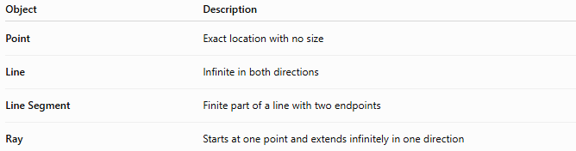
Object | Description
Point | Exact location with no size
Stright Line | Infinite in both directions
Line Segment | Finite part of a line with two endpoints
Ray | Starts at one point and extends infinitely in one direction

Key Points
# Source: AI Source: Provided by: [Data Path: Persons Table -> ID Column: 1, Name_En Column: Motasem Essam] -> From: [ChatGPT] on [7/25/2026]
- A Line extends infinitely in both directions.
- It has length only (one dimension).
- It has no endpoints.
- It contains infinitely many points.
- A line is commonly represented by:
$$\overset{↔}{AB}$$
- Stright Lines are fundamental in geometry, engineering, architecture, CAD, surveying, and computer graphics.

Conclusion
# Source: AI Source: Provided by: [Data Path: Persons Table -> ID Column: 1, Name_En Column: Motasem Essam] -> From: [ChatGPT] on [7/25/2026]
A Line is a fundamental one-dimensional geometric object that extends infinitely in both directions and serves as the basis for describing direction, alignment, and geometric relationships. Defined by any two distinct points, a line has length but no width or thickness and forms the foundation for many geometric constructions and coordinate systems. Stright Lines are essential in plane geometry, coordinate geometry, engineering, architecture, construction, CAD, surveying, robotics, GIS, and computer graphics, where they are used to model paths, boundaries, alignments, and structural designs.

